Name:
Date:
Class:
The Steps on creating a hero!

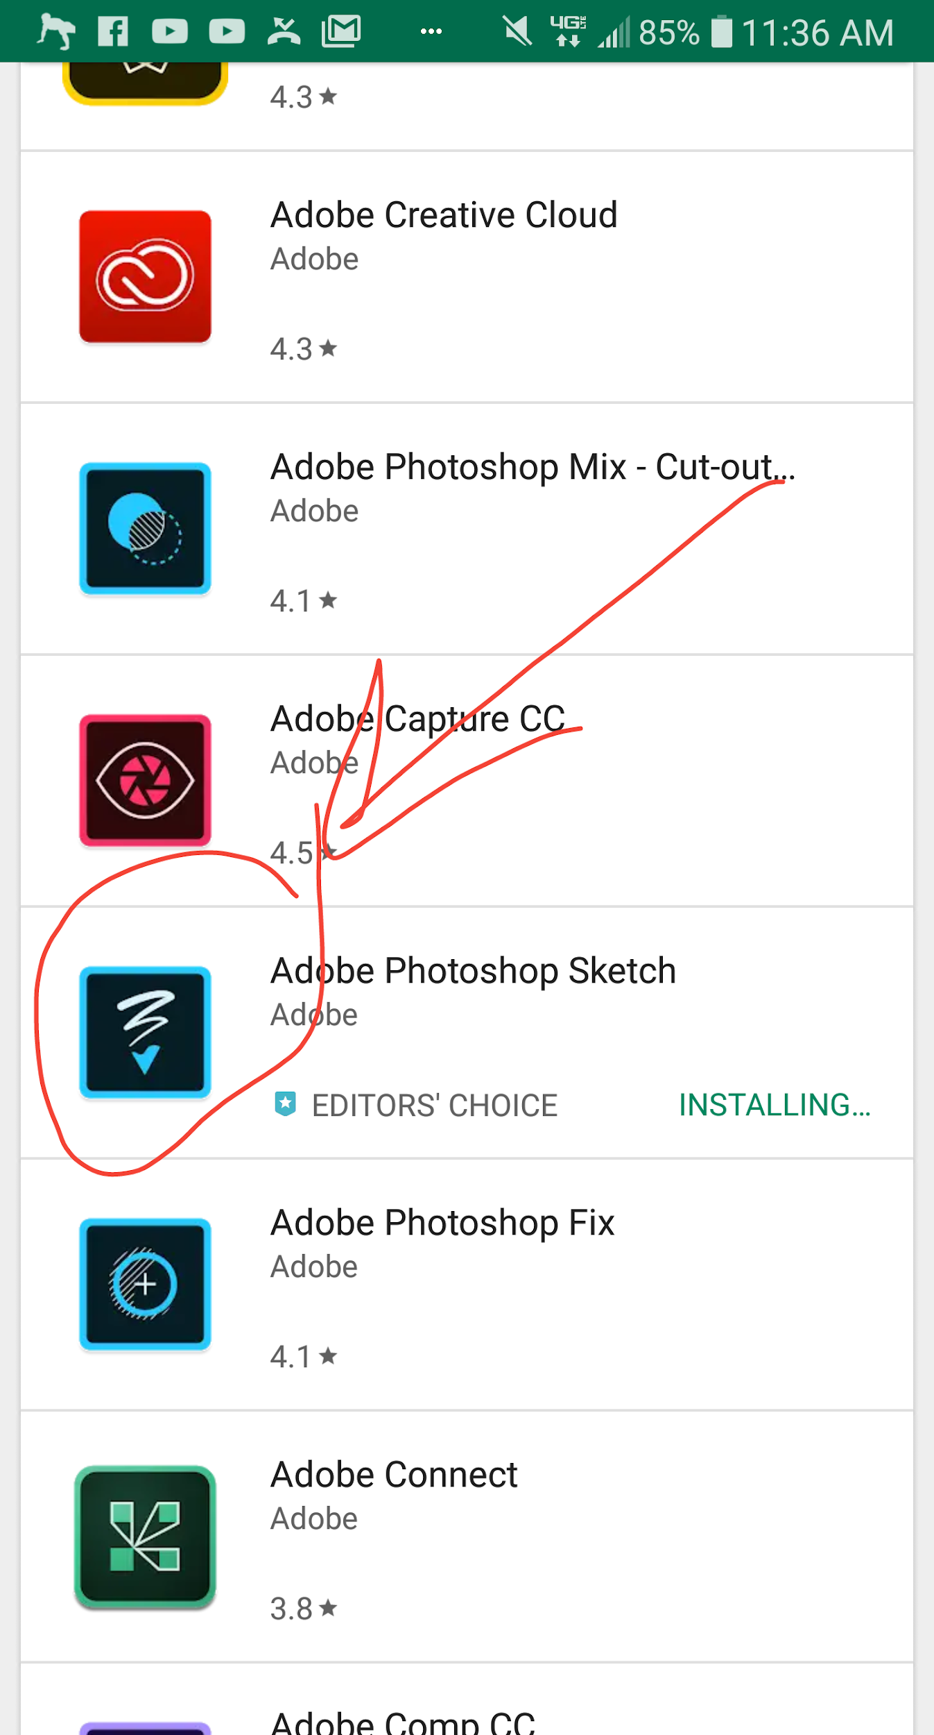  Step 1 | 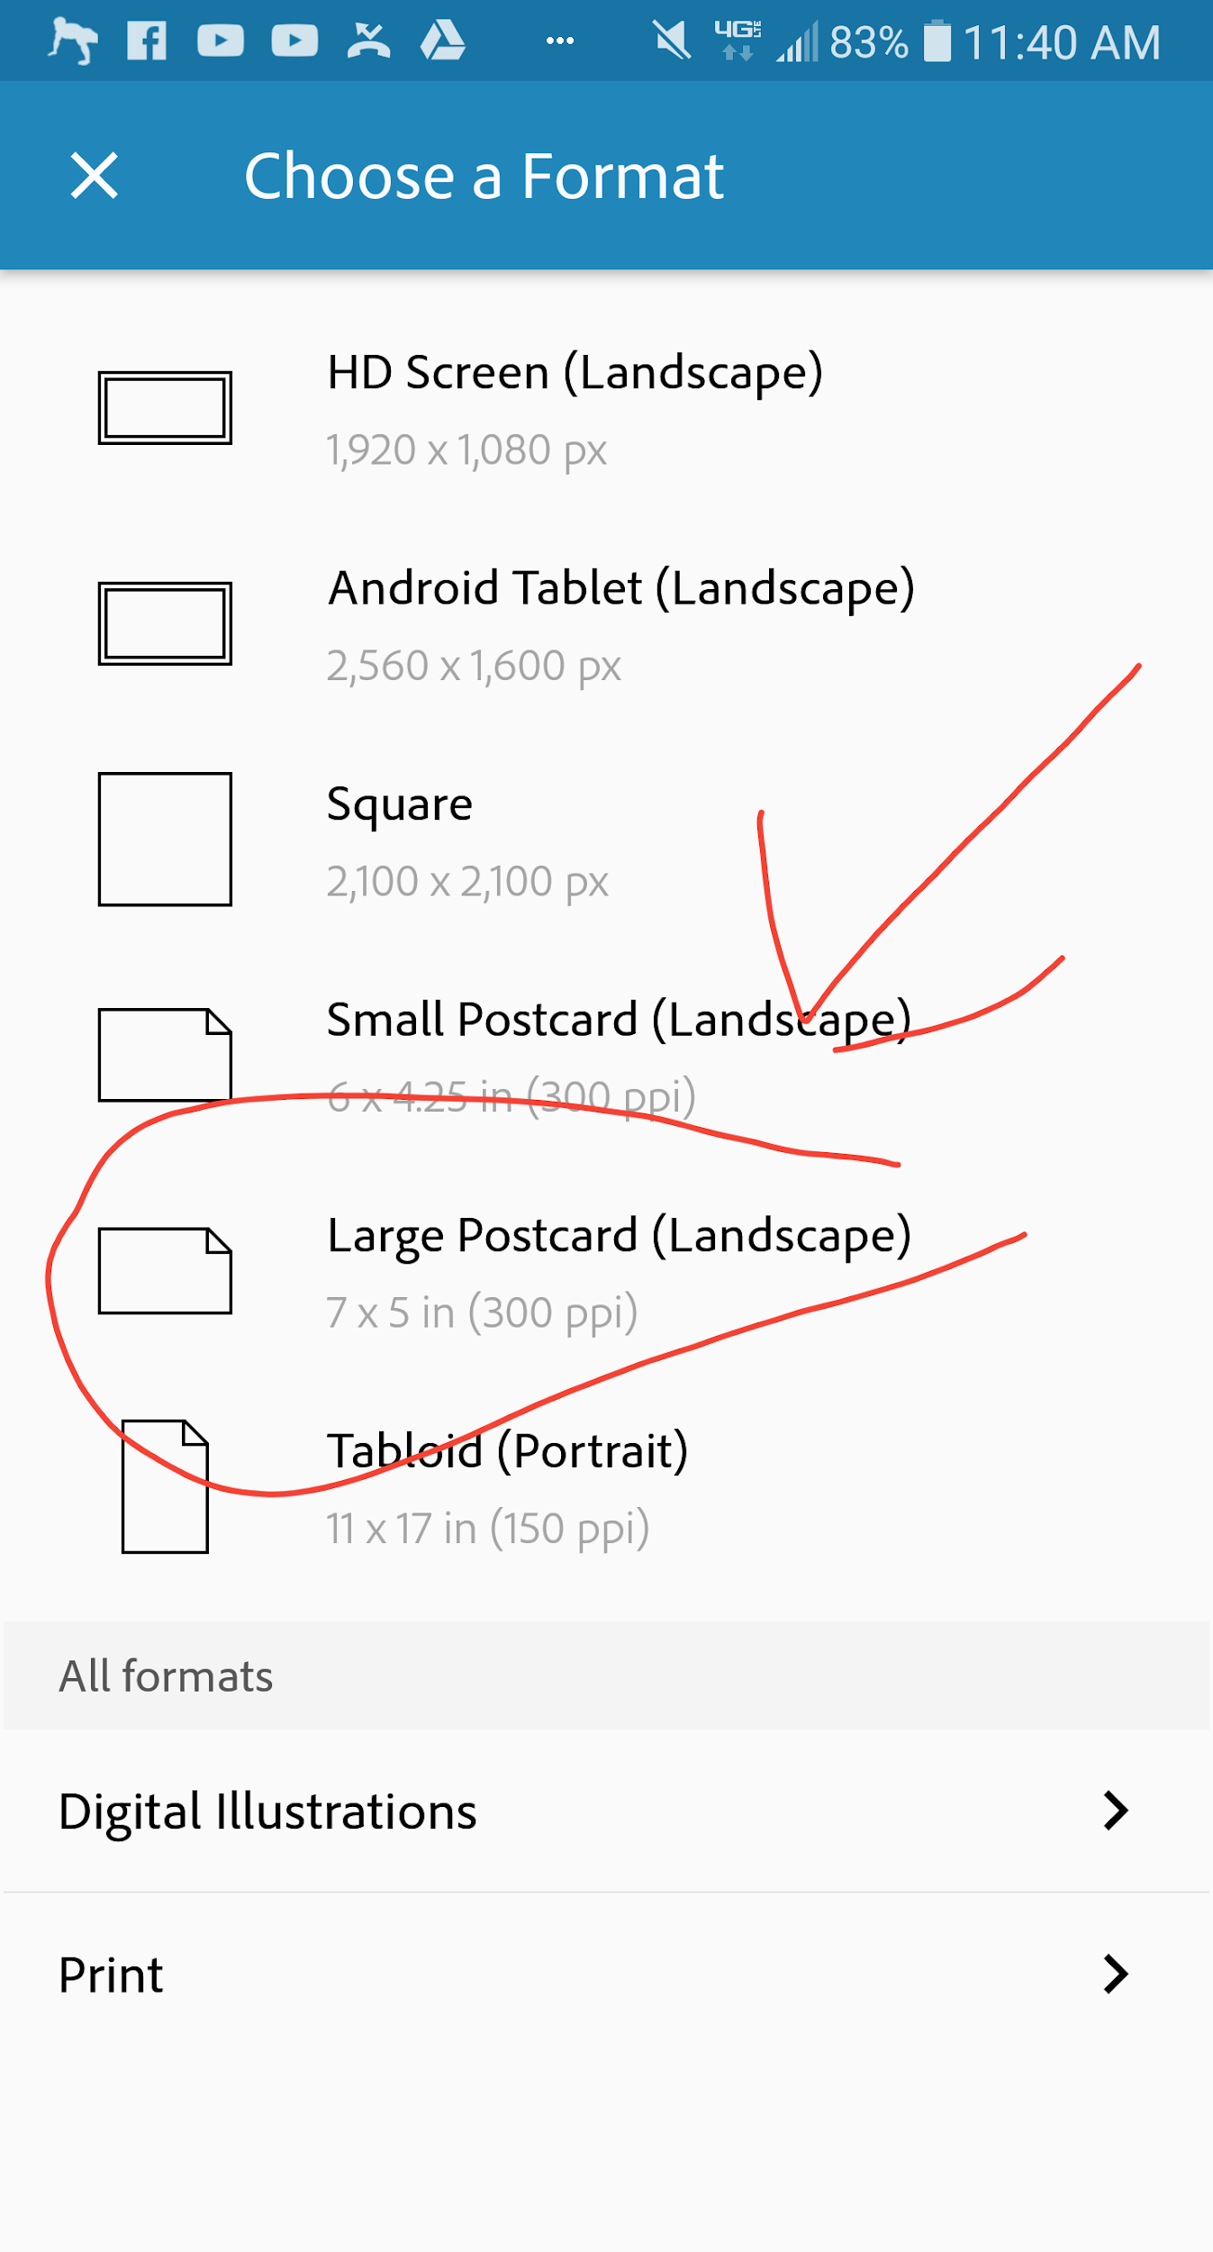  Step 3 | 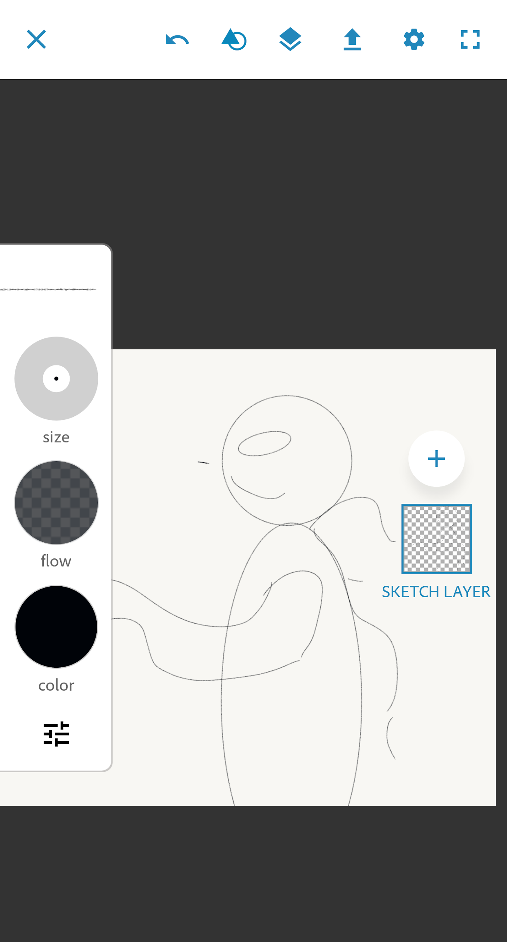  Step 4 | 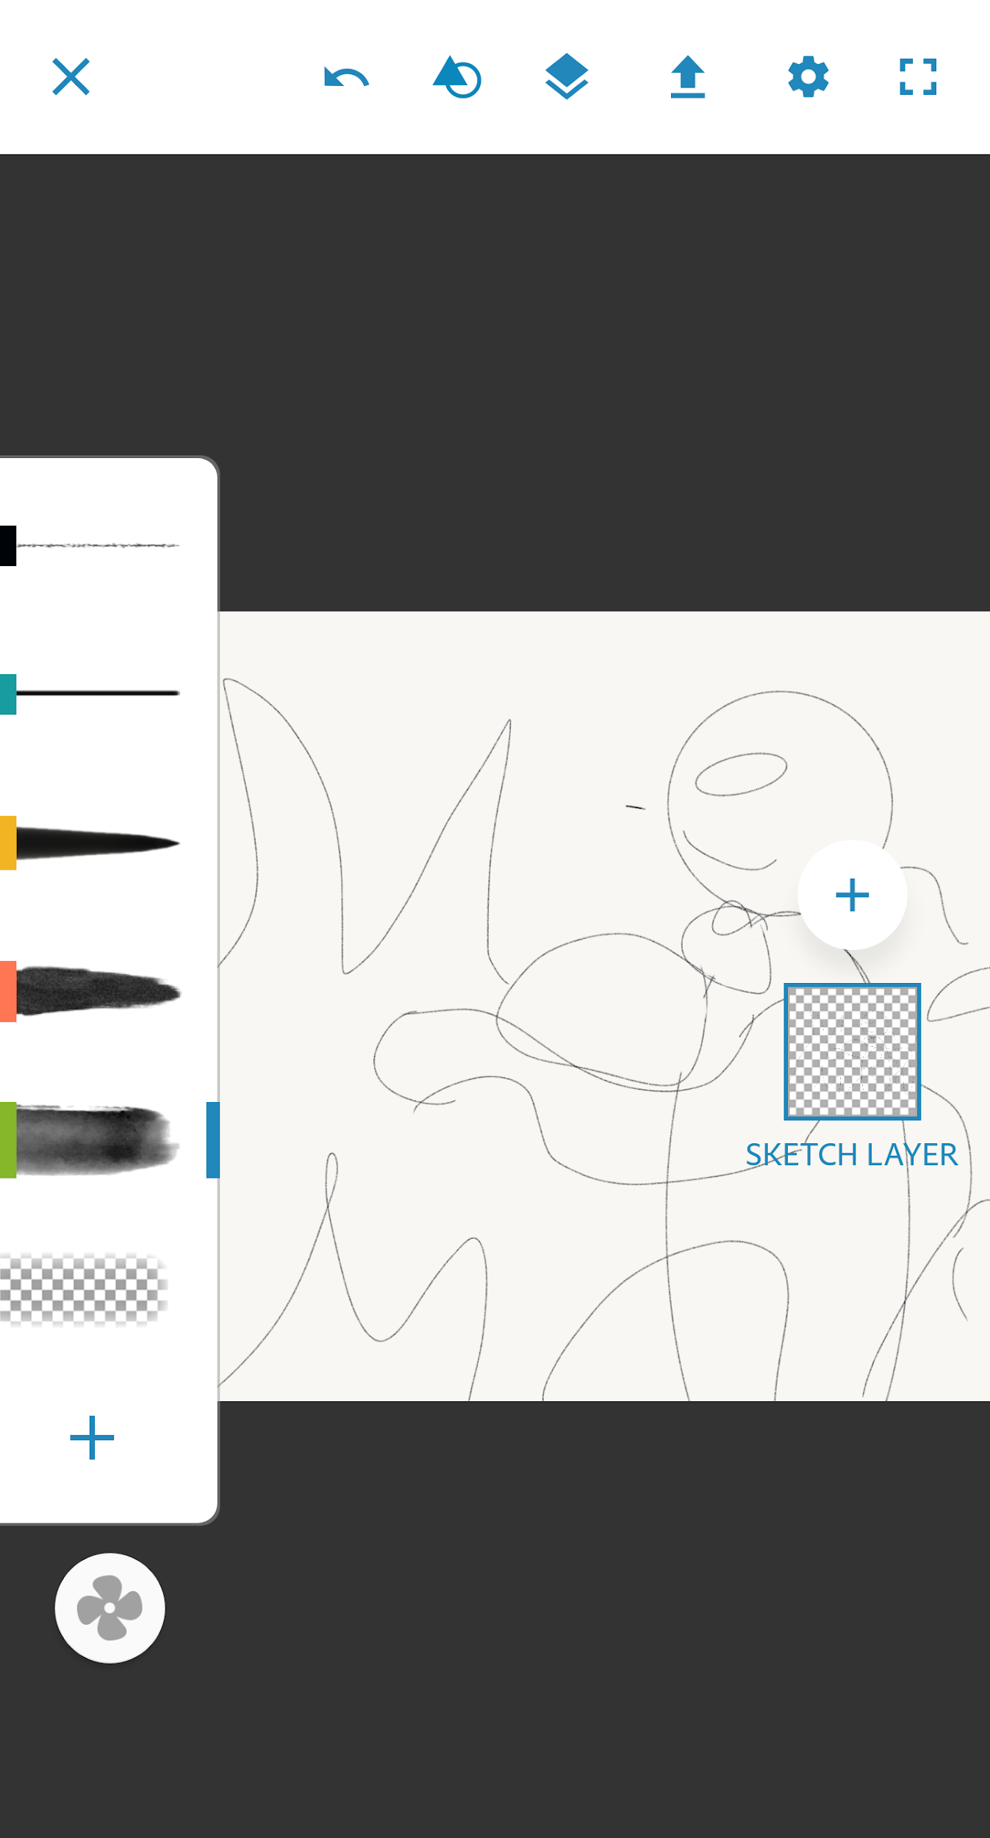  Steps 5&6 | 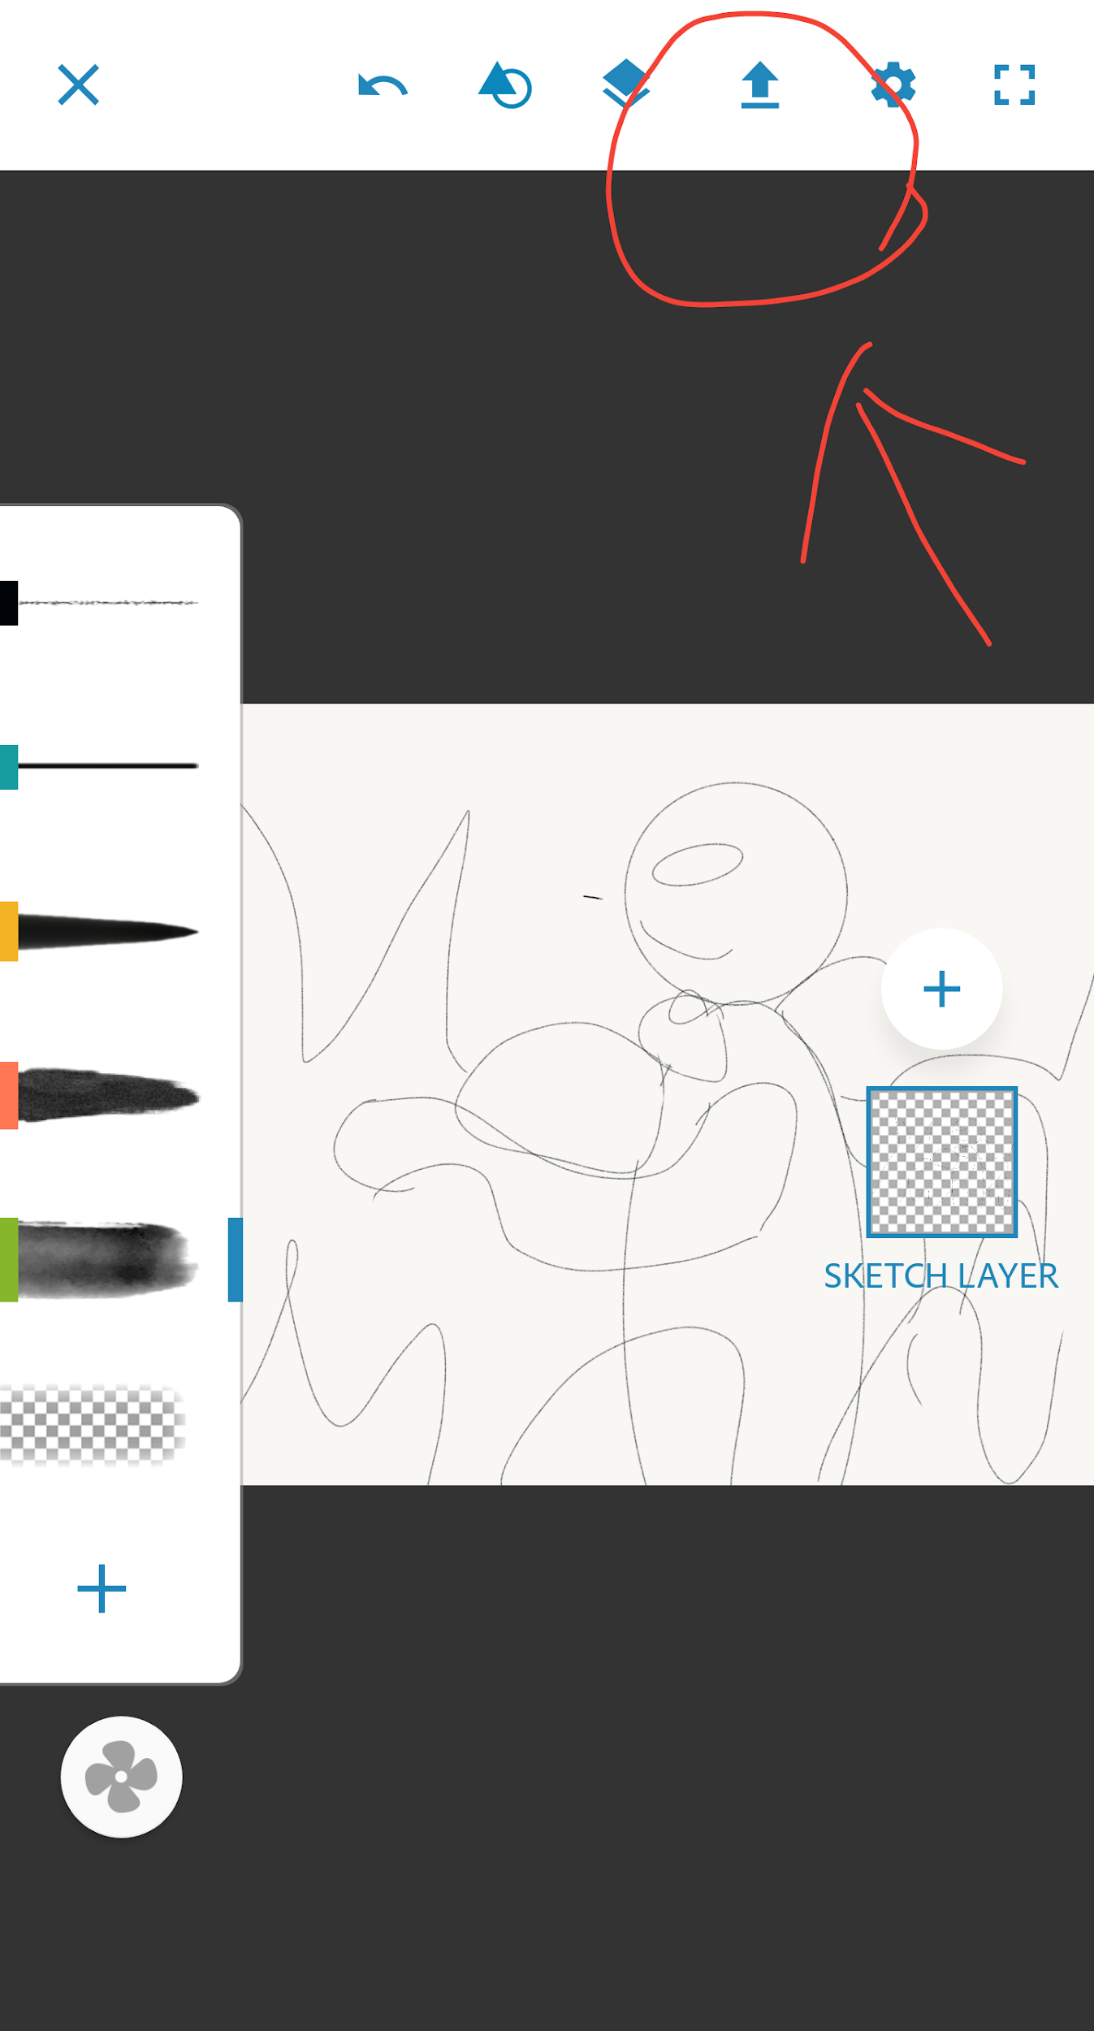  Step 7

Step 1! Go to the google play store and download the Adobe Sketch app
Step 2! Do the worksheet! (Fill out the worksheet for ideas and get started when your downloading!)
Step 3! Get started! Choose a new project, make sure it's 7×5in or the postcard template
Step 4! Make the basic shape of your character(s)
Step 5! Add any desired items in the foreground!
Step 6! Add a background!
Step 7! Save as to your phone’s gallery!
Step 8! Send to the teacher as an email!
Step 9! Pat yourself on the back you made a superhero!

