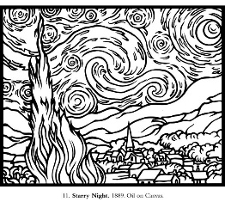
Van Gogh Virtual Museum Field Trip
Name:____________________________
Take your time to go through the museum and look through the artworks displayed.
While going through the exhibition think about how to answer these questions below and write down your answer.
Why did Van Gogh Idealize the Peasant lifestyle and why is it exemplified in most of his work?

Look for the painting titled “The Potato Eaters” from 1885. What do you see in this artwork?

What elements and principles of art are being used in this piece?

Do you think this artwork is successful, why or why not?

Make sure to read the captions on the walls of the room that “The Potato Eaters” is hanging. What is the purpose of this artwork?

Is the meaning of the work catered toward a certain audience?

How does Van Gogh use the elements to portray a mood and reflect the purpose and meaning of the work?

After exploring the whole museum answer these questions:
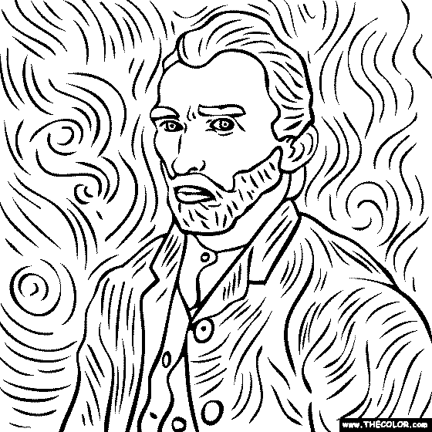
Why are so many of his paintings related to nature?

What type of art is the “root of everything?”

